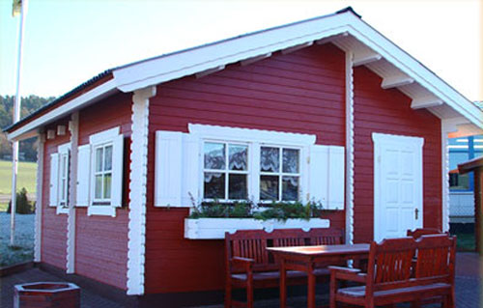 | 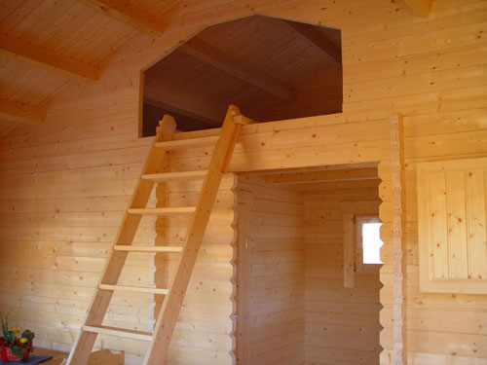
Kaiserforst 5.1m x 4.7m
Roof projection: Front 0.60 m
Back 0.50 m
Side 0.50 m

Prices:

45mm: £6,645
60 mm: £7,750

Consisting of:

Walls: from 45mm walls with double tongue and groove
4 thread clamping bars
Floor Timber: from 20 mm tongue and groove on impregnated basic frame
Roof Timber: from 20 mm tongue and groove on glued purlins
Second Floor: from 28 mm tongue and groove
Doors: 1 door 90/196
2 doors 70/196
Windows: 5 double-glazed windows

Roof tiles not included

Extras:

Shutters: Call for price
Double floor: Call for price
Surcharge for 1 log higher: 45mm £125
60mm £176

